**File Note**

**Site inspection for SCC on Part of Lot 4 DP 844371 and Part of Lot 1 DP 1018270, Bonny View Drive, Bonny Hills**

**Date: 26/05/2022**

The site is located on the corner of Ocean Drive and Bonny View Drive, between Lake Cathie and Bonny Hills (Photographs 1 & 2).

The land is relatively flat and covered in grasses and mature native vegetation. From the road, the site appears to be heavily vegetated (Photograph’s 3 – 6).

Surrounding the subject land is large lot residential to the north (Photograph 7 & 8). Directly adjoining the site to the south, west and east is undeveloped rural land (apart from single dwellings). Directly opposite the subject land is undeveloped residential zoned land whilst further to the south along Ocean Drive is highly concentrated general residential development.

Traffic along Ocean Drive was low to moderate during inspection time (1pm). There is relatively good site distance entering Ocean Drive from Bonny View Drive. There is a right turning land off Ocean Drive into Bonny View Drive.

No pedestrian facilities exist in the road reserve.

Gina Davis

Senior Planner, Northern Region

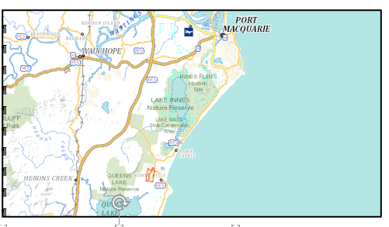

Subject site

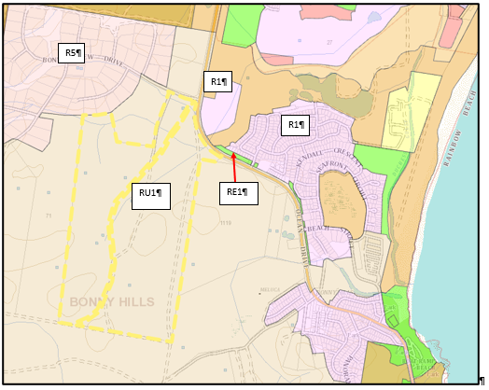 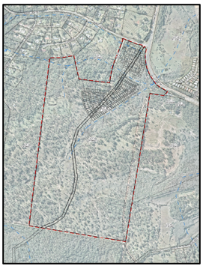

Subject site

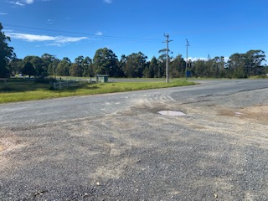

1. View from Bonny View Drive looking towards Ocean Drive and Bonny View Drive intersection

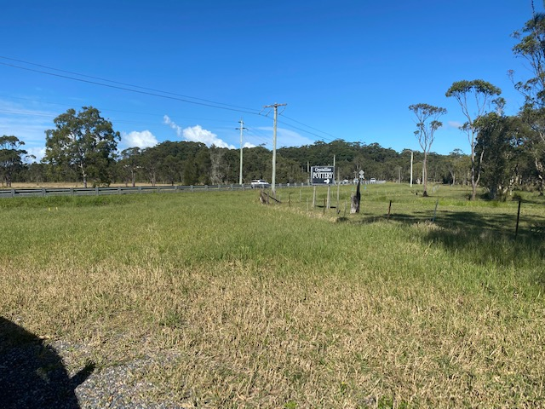

1. View from Bonny View Drive towards Ocean Drive

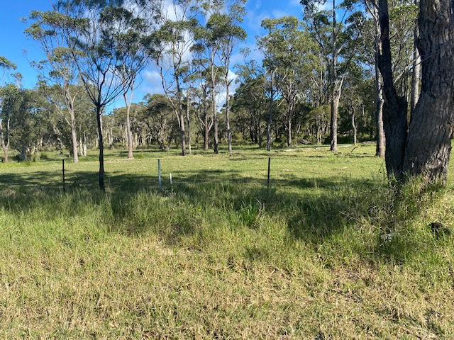

1. View from Bonny View Drive looking south towards Bonny Hills

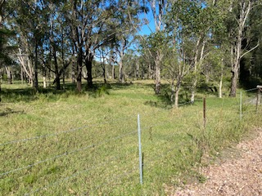

1. Vegetation as viewed from unnamed road (off Bonny View Drive) looking east towards Ocean Drive

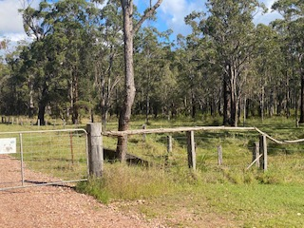

1. Vegetation as viewed from unnamed road (off Bonny View Drive) looking south towards Bonny Hills

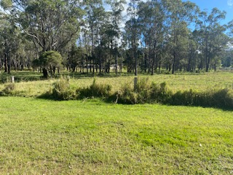

1. Vegetation as viewed from unnamed road looking south towards Bonny Hills

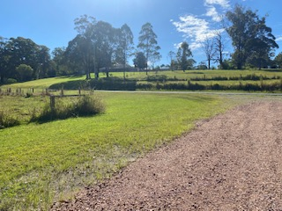

1. View from unnamed road (off Bonny View Drive) looking north towards Large Lot Residential development

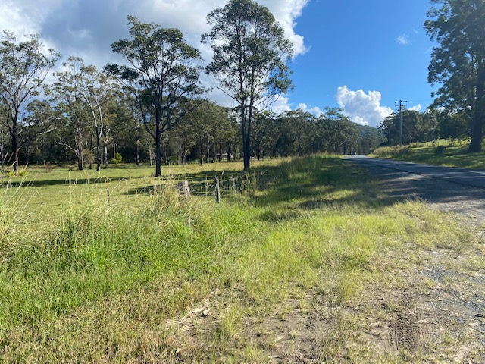

1. View from Bonny View Drive looking west along Bonny View Drive